Cambridge Hospital

Batch. | 2407G2
Group. | A
Serial No. | Enrollment Number | Student Name
1. | Student1594552 | DUA SHAHID
2. | Student1586656 | KIRAN AKBAR
3. | Student1594544 | SYEDA KASHMALA QASIM
4. | Student1594540 | SHUMA REHMAN
5. | Student1597223 | KAHSHAH
6. | Student1597226 | SYEDA ABEER HASAN

User Guide

1.Welcome (0.Welcome.html)

Figure 1: Welcome Page To Cambridge Hospital.

2.Layout Top

- Home Page (1.Index.html)
- About Us Page (2. About Us.html)
- Contact Us Page (3. Contact Us.html)
- Service (4. Service.html)
- Pricing(5.Pricing.html)
- Department(6.department.html)
- Department-detail(7.department-details.html)

3.Layout Bottom.
Footer
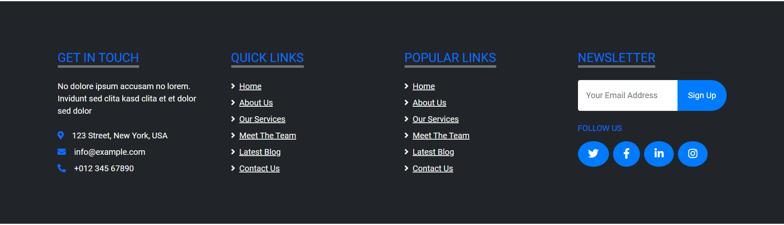

Figure 5 : Layout Bottom.

4.About us page (aboutus.html)
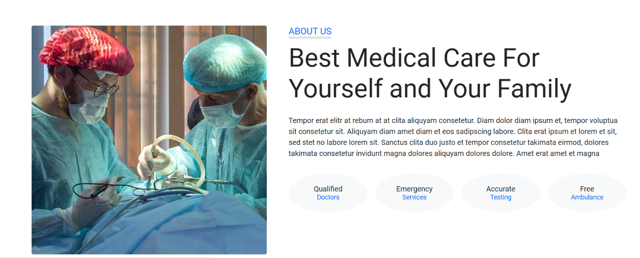

5.Service page (service.html)

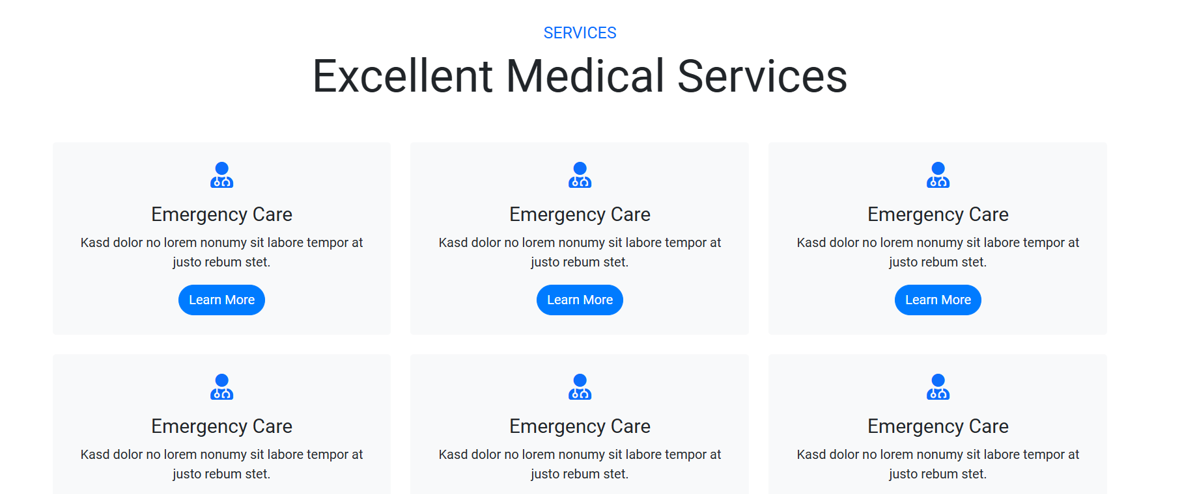

6.Pricing page (pricing.html)


Service page (service.html)

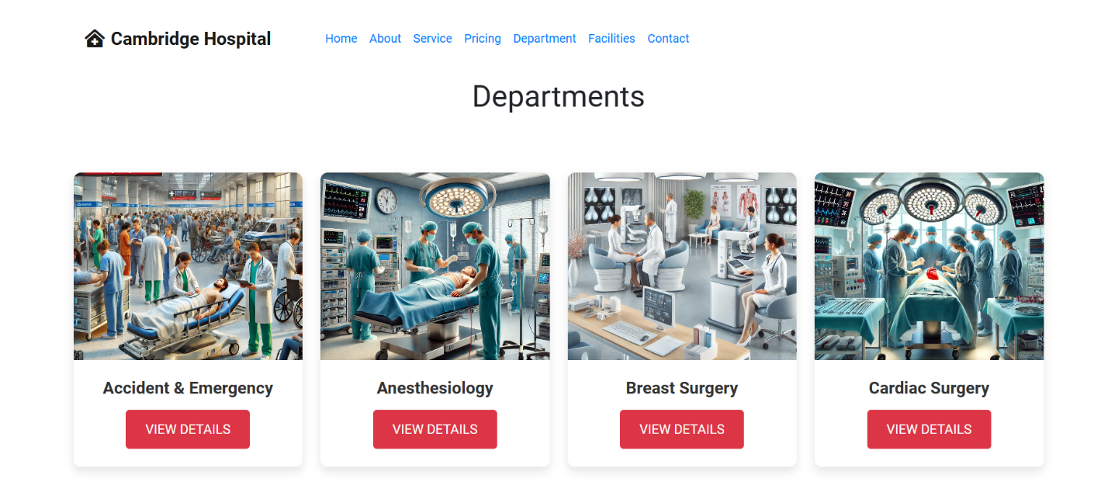
Department page(department.html)
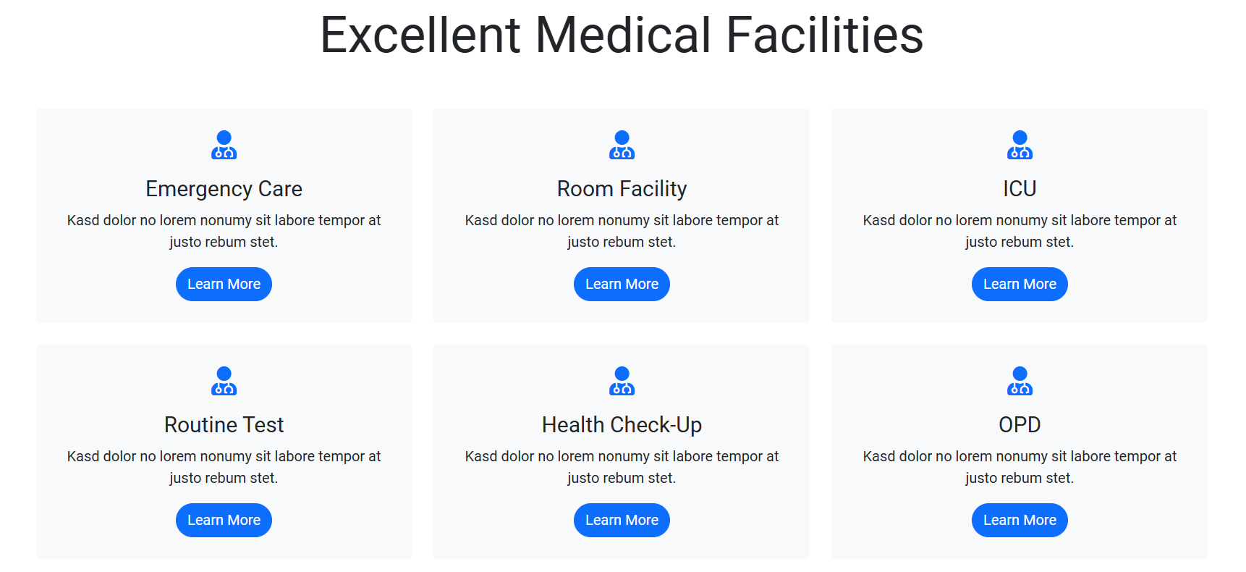
Facilities page( facilities.html)



